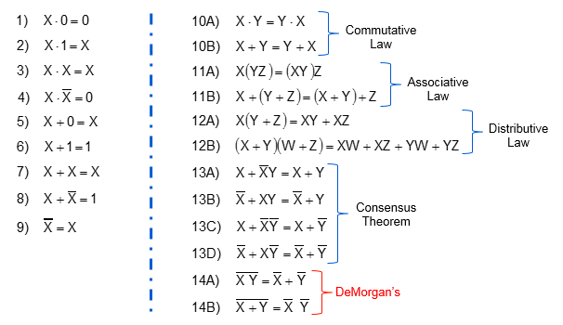



15. Modified Distributive Law (Used in example question; not really a different law just good to know)

(x+y)(x+z) = x2 + xz + xy + yz

= x + xz + xy + yz

= x(1 + z + y) + yz

= x + yz

More details on the laws:

1. x && false == false (it’s false because not both are true)
2. x && true == x (it’s true; only if x is true)
3. x && x == x (obvious)
4. x && !x == false (cannot make both x and not x true)
5. x || false == x (depends on whether x is true or not; ignores other because it is false)
6. x || true = true (doesn’t matter what x is; it’s already true 🡪 short-circuiting)
7. x || x == x (obvious 🡪 same as #3)
8. x || !x == true (you already covered all the possibilities, it has to be true)
9. !(!x) == x (double negative = positive)

**10. Commutative Law**

* “Commute” 🡪 they can switch places and remain the same
* xy = yx

**11. Associative Law: Similar to commutative**

* (xy)z = x(yz)
* 3 terms
* If you do the first two first it’s the same as doing the last two first
* Same logic applied for Boolean addition

**12. Distributive Law**

* You can decompose
* Factored form is the same as the simplified form

**13. Consensus Theorem**

* If x OR y are true, then x is true OR x is false (!x 🡪 negation of x is true) then y must be true.
* **(x || y)** == **x || (!x && y)**
* The other three are just the first one but negating either x, y or both.
  + For example:
  + **(x || !y)** == **x || (!x || !y)**

**14. DeMorgan’s Laws**

* !(x && y) == !x || !y
* !(x || y) == !x && !y

**Example AP-Style Questions:**

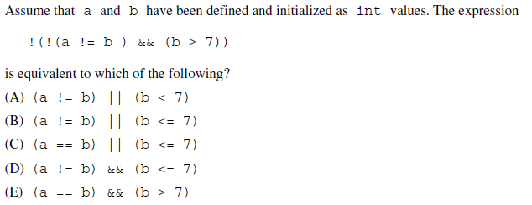



! (! (a != b) && (b > 7))

= ! ((a == b) && (b > 7))

= !(a == b) || !(b > 7)

= (a != b) || (b <= 7)

**Therefore the answer is (D).**

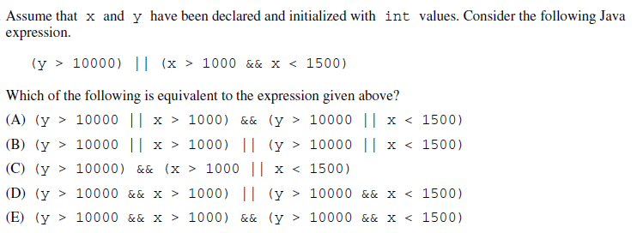



**Use law #15 (modified distributive), realize that it has to be (A).**

It’s easiest to sub in the numbers for this one and say that y> 10000 OR 1000<x<1500 and compare to the options.